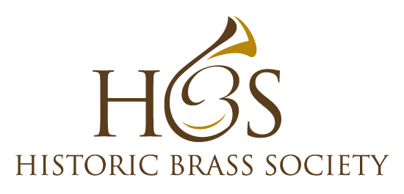

Making the Jazz Gumbo
An International Conference on
Repertoires that Influenced and were Influenced by Early Jazz

Presented by the
Historic Brass Society
With support from the
City University Of New York Graduate Center
National Jazz Museum in Harlem
Marking the 100th Anniversary of the death of James Reese Europe

May 8, 2019
CUNY Graduate Center
365 5th Avenue, NYC

Pre-Conference Social Event
National Jazz Museum in Harlem
58 West 129th Street, NYC
Tuesday May 7, 2019 6:00 PM

Jimmy Owens and Bobby Sanabria – Co-Musical Directors
Jeff Nussbaum and John Graziano – Co-Conference Directors

Scholars and Performers to include: Jason Moran, Ehud Asherie, Frederick Starr, Jack Stewart, Michael Dinwiddle, Ned Sublette, Krin Gabbard, Ralph Barrett, Leslie K. Haynes, Paul Niemisto, Thomas Garcia, Laura Moore Pruett, Robin Moore + 20 Piece Period-Instrument Band

As with a great gumbo, the creation of musical genres involve the mix of many elements. Some of those elements have been downplayed in jazz history. This conference aims to address those shortcomings and will focus on musical styles that helped create and were influenced by jazz. Special focus will be placed on James Reese Europe and the Harlem Hell Fighters who created a link between ragtime and early jazz as well as what Jelly Roll Morton intriguingly called “That Spanish tinge.” Exploration of cross-influences from Latin American music will be explored, most notably, early Cuban repertoire. Brazilian choro, maxixe and other styles as well as repertoire from Puerto Rico, and Mexico will be included. Music and history of composers such as Louis Moreau Gottschalk, Pixinguinha, and Ernesto Nazareth will also be represented.

The conference will end with a period-instrument concert of the music of James Reese Europe and the Harlem Hell Fighters as well as late 19th and early 20th century music of Cuba, Puerto Rico, Mexico, Brazil and works by Gottschalk, Pixinguinha, Nazareth, Jelly Roll Morton, Wm. Tyers, Lucky Roberts and others.

www.historicbrass.org president@historicbrass.org
Making the Jazz Gumbo
An International Conference on
Repertoires that Influenced and were Influenced by Early Jazz

Registration Form
Mail to: HBS 148 West 23rd Street #5F New York, NY 10011

Name: ___________________________________________________________________

Email:______________________________________________________________________

Phone: ______________________________________________________________________

Mailing Address: _______________________________________________________________

[ ] Conference Free: $25 (checks payable to: Historic Brass Society)

[ ] Full-Time Students: Gratis

[ ] Conference Participants: Gratis

[ ] Evening Concert: Free of Charge

[ ] I plan on attending the pre-conference social event at the National Jazz Museum in Harlem 7:30 PM

[ ] I am not an HBS member but would like to join. $42. Student and Senior Membership $35. Checks payable to Historic Brass Society

